Anthony Cunningham

Experimental Design & Analysis

Professor Erning Li

2/14/2018

**Homework 3 Code and Output**

#1.

> cement <- read.table("http://www.stat.uiowa.edu/~ernli/DOEdata/problem0311.txt", header=TRUE)

> summary(aov(Strength ~ factor(Technique), data=cement))

Df Sum Sq Mean Sq F value Pr(>F)

factor(Technique) 3 489740 163247 12.73 0.000489 ***

Residuals 12 153908 12826

> par(mfrow=c(1,2))

> boxplot(Strength ~ Technique, cement)

> plot(Strength ~ Technique, cement)



> a=4

> n=4

> dfError=a*(n-1)

> msError=12826

> tcritical=qt(0.025, dfError, lower.tail=FALSE)

> SE=sqrt(2*msError/n)

> fisherLSD=tcritical*SE

> fisherLSD

[1] 174.482

> library(emmeans)

> cementLM <- lm(Strength ~ factor(Technique), data=cement)

> lsmeans(cementLM, pairwise ~ Technique, adjust="none")

$contrasts

contrast estimate SE df t.ratio p.value

1 - 2 -185.25 80.08023 12 -2.313 0.0392

1 - 3 37.25 80.08023 12 0.465 0.6501

1 - 4 304.75 80.08023 12 3.806 0.0025

2 - 3 222.50 80.08023 12 2.778 0.0167

2 - 4 490.00 80.08023 12 6.119 0.0001

3 - 4 267.50 80.08023 12 3.340 0.0059

> qqnorm(residuals(cementLM))

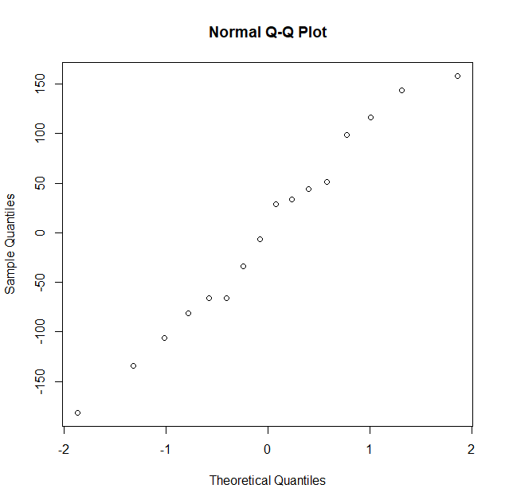

> plot(fitted(cementLM), residuals(cementLM))

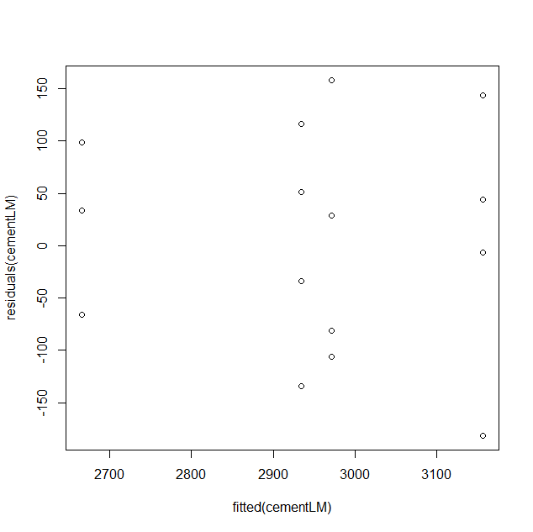

> bartlett.test(Strength ~ factor(Technique), data=cement)

Bartlett test of homogeneity of variances

data: Strength by factor(Technique)

Bartlett's K-squared = 0.71158, df = 3, p-value = 0.8705

#2.

> lsmeans(cementLM, pairwise ~ Technique)

$contrasts

contrast estimate SE df t.ratio p.value

1 - 2 -185.25 80.08023 12 -2.313 0.1494

1 - 3 37.25 80.08023 12 0.465 0.9653

1 - 4 304.75 80.08023 12 3.806 0.0116

2 - 3 222.50 80.08023 12 2.778 0.0693

2 - 4 490.00 80.08023 12 6.119 0.0003

3 - 4 267.50 80.08023 12 3.340 0.0262

P value adjustment: tukey method for comparing a family of 4 estimates

> pairwise.t.test(cement$Strength, cement$Technique, p.adjust.method="bonferroni")

Pairwise comparisons using t tests with pooled SD

data: cement$Strength and cement$Technique

1 2 3

2 0.23544 - -

3 1.00000 0.10019 -

4 0.01503 0.00031 0.03530

P value adjustment method: Bonferroni

#3.

> batteryLife <- read.table("http://www.stat.uiowa.edu/~ernli/DOEdata/problem0330.txt", header=TRUE)

> anova(lm(Life ~ factor(Brand), data=batteryLife))

Analysis of Variance Table

Response: Life

Df Sum Sq Mean Sq F value Pr(>F)

factor(Brand) 2 1196.1 598.07 38.338 6.141e-06 ***

Residuals 12 187.2 15.60

> batteryLifeLM=lm(Life ~ factor(Brand), data=batteryLife)

> qqnorm(residuals(batteryLifeLM))

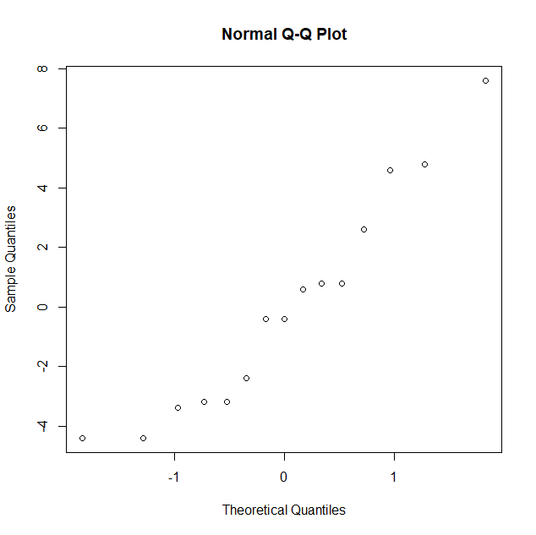

> plot(fitted(batteryLifeLM), residuals(batteryLifeLM))

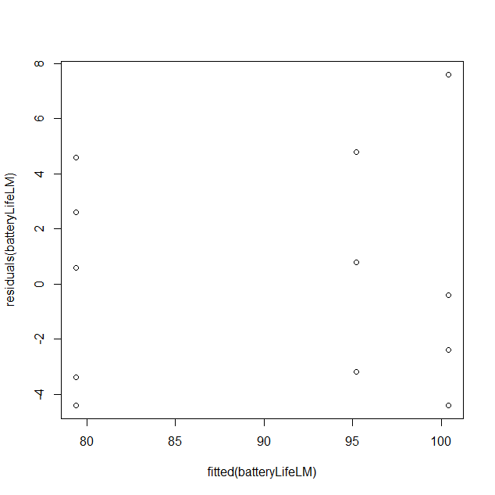

> linearHypothesis(batteryLifeLM, c(0.5, 0.5, -1), rhs=0)

Linear hypothesis test

Hypothesis:

0.5 ((Intercept) + 0.5 factor(Brand)2 - factor(Brand)3 = 0

Model 1: restricted model

Model 2: Life ~ factor(Brand)

Res.Df RSS Df Sum of Sq F Pr(>F)

1 13 2832.2

2 12 187.2 1 2645 169.55 1.937e-08 ***

> linearHypothesis(batteryLifeLM, c(1, -0.5, -0.5), rhs=0)

Linear hypothesis test

Hypothesis:

(Intercept) - 0.5 factor(Brand)2 - 0.5 factor(Brand)3 = 0

Model 1: restricted model

Model 2: Life ~ factor(Brand)

Res.Df RSS Df Sum of Sq F Pr(>F)

1 13 11409.7

2 12 187.2 1 11222 719.39 4.432e-12 ***

> a=3

> n=5

> dfError=a*(n-1)

> msError=15.6

> tcritical=qt(0.025, dfError, lower.tail=FALSE)

> SE=sqrt(2*msError/n)

> fisherLSD=tcritical*SE

> fisherLSD

[1] 5.442673

> qcritical=qtukey(0.05, a, dfError, lower.tail=FALSE)

> tukeyHSD=qcritical*SE

> tukeyHSD

[1] 9.424774

> fcritical=qf(0.05, a-1, dfError, lower.tail=FALSE)

> scheffeMSD=fcritical*SE

> scheffeMSD

[1] 9.705461

> library(multcomp)

> brand <- as.factor(batteryLife$Brand)

> batteryLife.aov <- aov(Life ~ brand, batteryLife)

> batteryLife.Dunnett <- glht(batteryLife.aov, linfct=mcp(brand="Dunnett"))

> summary(batteryLife.Dunnett)

Simultaneous Tests for General Linear Hypotheses

Multiple Comparisons of Means: Dunnett Contrasts

Fit: aov(formula = Life ~ brand, data = batteryLife)

Linear Hypotheses:

Estimate Std. Error t value Pr(>|t|)

2 - 1 == 0 -15.800 2.498 -6.325 7.28e-05 ***

3 - 1 == 0 5.200 2.498 2.082 0.104